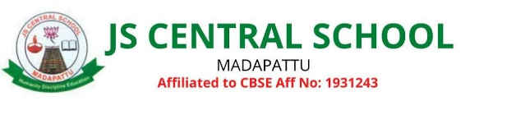
List of Parents Teachers Association (PTA) Members 2023 – 24
S.No | Member Name | Qualification | Designation | Phone No
1 | Mr.Subramani M | M.Pharm | Chairman | 9789554824
2 | Mrs.Jayalakshmi k | M.Sc.,B.ed | Secretary | 8056978970
3 | Mrs.Praveen Selva  Kumari A | B.Sc., B.ed | Treasurer | 9944289331
4 | Mrs. Vaithegi T | M.A.,B.ed | Teacher Member | 8610159049
5 | Ms.Hemavathy R | B.A.,B.ed | Teacher Member | 7397672195
6 | Mrs.Arockya Daisy Suguna C | B.A., | Teacher Member | 6382658432
7 | Mr.Bharathidasan T | M.Sc., B.ed | Teacher Member | 8508018004
8 | Mrs.Anjugam | B.Com | Parent | 9688663570
9 | Mr.Prasanna G | B.E | Parent | 9894635238
10 | Mrs.Priya J | B.A | Parent | 8489922080
11 | Mrs. Vanitha S | HSC | Parent | 9597554307
12 | Mrs.Rajalakshmi B | D.Ted.,M.A.,B.ed | Parent | 9043060559
13 | Mr.Kesavaperumal P | SSLC | Parent | 9786162022
14 | Mr.Dhomin C | B.com | Parent | 8939429183
15 | Mr.KamalaKannan | M.Arch | Special Invitee | 8220069387

